# **Introduce**

Have 10 day for make Game.

## Setup Tools

* [Visual Studio Code](https://code.visualstudio.com/)
  + <https://marketplace.visualstudio.com/items?itemName=CoenraadS.bracket-pair-colorizer>
  + <https://marketplace.visualstudio.com/items?itemName=swashata.beautiful-ui>
  + <https://marketplace.visualstudio.com/items?itemName=ritwickdey.LiveServer>
* [Chrome](https://www.google.com/chrome/)

## Timeline

|  |  |
| --- | --- |
| **3 Day With Language** | **7 Day With Make Game** |
| Basic HTML, CSS, JS   * <https://www.w3schools.com/html/default.asp> * <https://www.w3schools.com/css/default.asp> * <https://www.w3schools.com/js/default.asp>   OOP   * <https://developer.mozilla.org/en-US/docs/Learn/JavaScript/Objects/Object-oriented_JS>   ES6   * <https://webapplog.com/es6/> * <https://codetower.github.io/es6-features/> | GameLoop  FPS  GameState  Resources  Texture, TextureCache  TextureAtlas  Sprite  window: keyboard  groupingSprites: node, child  Text, TextStyle  Audio: <https://howlerjs.com/> |

# **Project Structure**

Folder

|  |  |
| --- | --- |
| data | Data use in game: texture, sound, font, … |
| Src | Source code logic javascript |
| Index.html | Entry point web app |
| Index.js | Main app js |
| package.json | Define package library use in project. |

## 

## How to RUN

Install: ‘npm i’

Reun: ‘npm run dev’

Debug

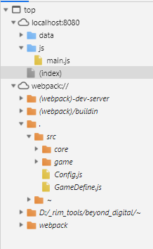

## PixiJS v4

Pixi is an extremely fast 2D sprite rendering engine. What does that mean? It means that it helps you to display, animate and manage interactive graphics so that it's easy for you to make games and applications using JavaScript and other HTML5 technologies. It has a sensible, uncluttered API and includes many useful features, like supporting texture atlases and providing a streamlined system for animating sprites (interactive images).

## **Make Game Now**

## 

## 

# **Reference**

Pixi Example Code

* <https://github.com/kittykatattack/learningPixi>

Demo source Game:

* <https://github.com/Bonnee/breakthefuckout/blob/master/BreakTheFuckOut/BreakTheFuckOut/www/game.js>